**Lab 03 Task**



**Name Hammad Arshad**

**Roll no SU92-BSAIM-F23-030**

**Section BSAI-4A**

**Subject PAI (LAB)**

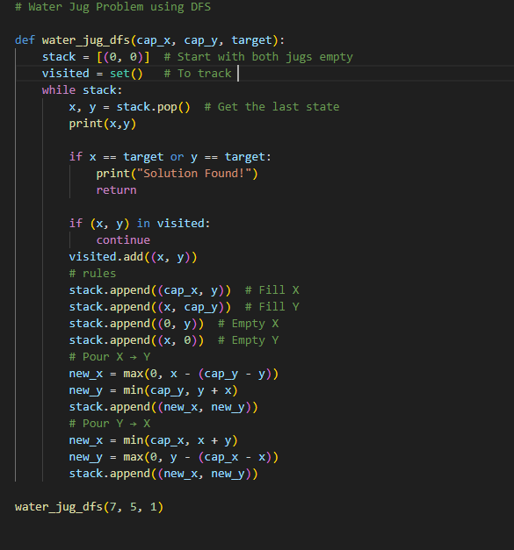

I implemented the **Water Jug Problem** using **Depth-First Search (DFS)**. This problem is about measuring a specific amount of water using two jugs with fixed capacities. The code explores all possible ways to fill, empty, or transfer water between the jugs until the required amount is reached.

**How the Code Works:**

1. **Starting Point:** Both jugs are empty at the beginning.
2. **Operations Used:**
   * Fill a jug completely.
   * Empty a jug.
   * Pour water from one jug to another until the second jug is full or the first jug is empty.
3. **Using DFS:** The program explores all possible states (water levels in both jugs) and checks if the target amount is reached.
4. **Avoiding Loops:** A set is used to track visited states, preventing infinite repetitions.
5. **Stopping Condition:** When the required amount appears in any jug, the solution is found, and the program stops.

**Why This?**

DFS is used because it explores each possibility deeply before backtracking. It’s a simple way to solve this type of state-based problem efficiently. The output shows a step-by-step process of how water moves between the jugs until the target amount is achieved.